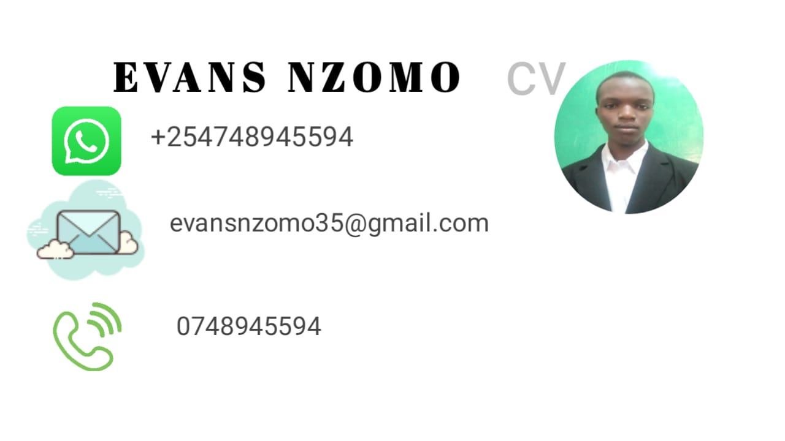

**Summary:**

I am a qualified, skilled, and experienced personnel in the field of computing. Specialized in the frontend development of software and phone applications.

**Education:**

**tertiary**

Degree – Bachelor of Science in computer science and Technology

Major – software engineering

Institution- South Eastern Kenya University

Year of Graduation –

**Secondary**

Institution - Kitaingo Boys High School

Grade attained – B Plain

Year of completion – 2021

**Primary**

Institution- Kwakathendu Primary School

Grade attained – B / 300 marks

**Work Experience**:

[graphic-designer] [self-employed] [2023]

Responsibilities- designing posters for businesses and organizations.

[software- developer] [self-employed] [2024]

Responsibilities- making websites and soft-wares for individuals and companies.

[data analyst] [freelance ] [2023-2024]

Responsibilities – entering and analyzing data using STATA and SPSS

**Skills:**

- Technical skills : programming languages;( c++, php, html, css, java), software proficiency, graphic designing, data entry

- Soft skills: communication, teamwork, leadership

**Achievements**

- I have achieved certificates of merits in primary, secondary, and university education, I have gained other certificates of leadership in institutions and clubs.

**Extracurricular:**

- I have various projects in the field of business and another in the field of mathematics.

A link to those projects is attached at the end of the document.

**References:**

DR. Omala Omundu- South Eastern Kenya University

PROF. Douglas shitanda- South Eastern Kenya University

MR. Mathew Kimuyu – Kitaingo Boys High School

MR. Justus Mutua - Kitaingo Boys High School

MR. Ndua – Kwakathendu primary school.